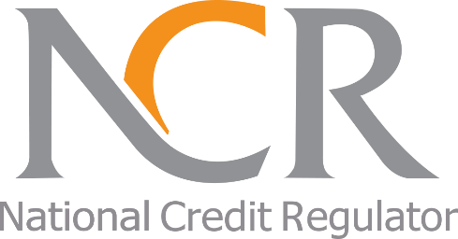
The National Credit Regulator
P.O.Box 209
Halfway House
1685
Tel: (011)554-2600/2700
Website: www.ncr.org.za

Media Release

For Immediate release October 2018

The National Credit Regulator issues a public warning about Charis Financial Services

The National Credit Regulator (NCR) has issued a public warning against Charis Financial Services, an unregistered credit provider, conducting business in Pietermaritzburg; KwaZulu-Natal.

Consumers are warned that loans extended by Charis Financial Services, are unlawful and may be void due to the fact that they are not a registered credit provider.

“Credit providers are reminded that as of October 2016 any person or entity that is involved in the provision of credit is required to be registered irrespective of the number of agreements and / or the value of the principal debt”, says Jacqueline Peters, Manager of the Investigations and Enforcement at the NCR.

“The NCR will continue with operations to monitor unregistered entities around the country and will bring applications to the National Consumer Tribunal to have credit agreements concluded by unregistered entities to be declared unlawful”, she added.

“Consumers are urged to ensure that they only apply for credit from credit providers who are registered with the NCR”, Peters concluded. If a consumer is unsure or in doubt about the legitimacy of the credit provider or a credit agreement, they should contact the NCR on (011) 554-2600/2700 or visit www.ncr.org.za.

ENDS

About The National Credit Regulator

The National Credit Regulator (NCR) was established as the regulator under the National Credit Act 34 of 2005 (the Act) and is responsible for the regulation of the South African credit industry. The NCR is mandated with the registration of Credit Providers, Credit Bureaus, Debt Counsellors, Payment Distribution Agents, and Alternative Dispute Resolution Agents; and monitoring their conduct in compliance with the National Credit Act as amended. The National Credit Regulator offers education and protection to consumers of credit in promotion of a South African credit market that is fair, transparent, accessible and dynamic.

For more information contact:

Media Office: media@ncr.org.za

Or

Lebogang Selibi
(011) 554-2722
E-mail: lselibi@ncr.org.za

