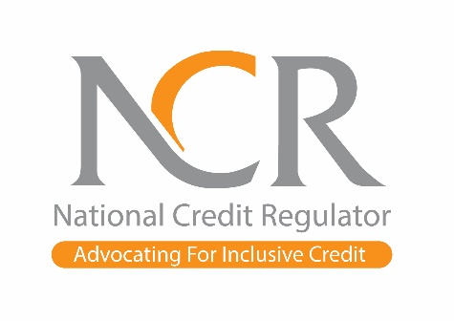

NATIONAL CREDIT REGULATOR URGES SOUTH AFRICANS TO SPEND WISELY AND AVOID A POST-FESTIVE “FINANCIAL HANGOVER”

DECEMBER 2025 IMMEDIATE RELEASE
Johannesburg – The National Credit Regulator (NCR) is calling on all consumers to exercise strict financial caution during this festive season to avoid starting 2026 overwhelmed by debt and financial distress. With approximately 10 million South Africans already over-indebted, the organisation warns that impulsive spending, social pressures, and easy access to credit continue to push many households into unsustainable financial situations. Although the South African Reserve Bank’s recent 25 basis-point repo rate reduction to 6.75% may provide short-term relief, the NCR cautions consumers not to misinterpret this as a licence for miscalculated spending.

“Each year, thousands of consumers begin January already burdened with unpaid debt, school expenses, and increased living costs, often worsened by festive overspending,” says Ms Lynette De Beer, Interim Chief Executive Officer at the NCR. “We are urging consumers to set clear financial boundaries, resist social pressure, and spend strictly within their means. This is a caution to South Africans to celebrate responsibly, by spending money wisely, so that they protect their financial future”.

Festive purchases, entertainment, travel and gifting often financed through credit may appear manageable in December but typically result in missed payments and long-term financial strain in the new year. Social expectations and online influences can easily tempt consumers into overspending, leading to prolonged hardship.
“As celebrations peak, so does the temptation to spend more. But the consequences can be severe. Therefore, we encourage all consumers to make mindful, affordability-based decisions to safeguard their financial wellbeing,” adds De Beer.

Consumers are urged to protect themselves by avoiding:
- High-interest loans to fund festive spending
- Reversing or skipping debit orders for “extra holiday money”
- Maxing out credit cards on non-essential purchases
- Buy-now-pay-later deals without understanding long-term costs
- Borrowing from unregistered or illegal credit providers
- Using credit for everyday household expenses

January is historically one of the most difficult financial months for South Africans. Overspending now can lead to payment defaults, increased debt accumulation, and ongoing financial stress.

“The NCR urges every consumer to pause, reflect, and make responsible spending decisions. Do not let short-term festive excitement jeopardise your financial stability in the year ahead,” concludes De Beer.

ENDS

Issued by: NCR - Corporate Communications

For media inquiries, please contact:
Ms Winnie Rabathata
National Credit Regulator (NCR)
Tel: (011) 554 2600 | Cellphone: 064 752 3923 Email: wrabathata@ncr.org.za Web: www.ncr.org.za
ABOUT THE NATIONAL CREDIT REGULATOR

The National Credit Regulator is tasked with regulating the South African credit industry, ensuring fair practices, promoting responsible lending, and protecting consumer rights under the National Credit Act.

