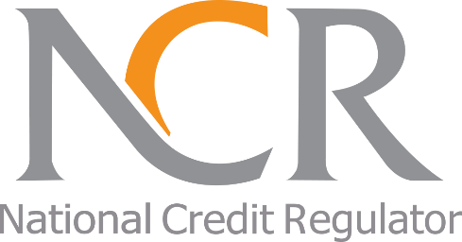
The National Credit Regulator
127-15th Road, Randjespark
Midrand
1685
Tel: (011)554-2600/2700
Website: www.ncr.org.za

MEDIA RELEASE
MARCH 2020

Know your Consumer Rights and be protected

March is Human Rights month and has also been adopted as a Consumer Rights month in South Africa. The 15th of March has been declared World Consumer Rights Day (WCRD) and consumer rights will be celebrated world-wide. The National Credit Regulator (NCR) is one of the consumer protection agencies, which celebrates WCRD and has also adopted the month of March as a consumer rights month. During the month of March, the NCR, intensifies its educational initiatives to advocate key consumer rights and responsibilities and to encourage the credit industry players to comply with the National Credit Act (NCA), says Adv. Kedilatile Legodi, Acting Manager: Education and Communication.

The NCR in collaboration with other members of the Consumer Protection Forum (CPF) (CPF is a government voluntary association of consumer protection bodies), will partake in the WCRD celebration on Friday, 13th March 2020 at the East London International Convention Centre in the Eastern Cape under the theme “Fighting Consumer Exploitation.”

This main event will be preceded by a build-up of various events comprising multiple stakeholders. These events will include both compliance monitoring and consumer education and awareness interventions in the Amathole District. In addition to these, the NCR will participate in a number of provincial interactive programmes and undertake awareness programmes using various mediums.

This year, the NCR continues to encourage consumers to know their credit rights to make informed credit decisions and speak up when there is a need to do so. Adv. Legodi believes that consumers can only exercise their rights and responsibilities if they are aware of such.

The National Credit Act provides for key consumer rights as listed below:
- Right to apply for credit –This application must be made in good faith with truthful disclosure of all information by the consumer. If the application is declined by the credit provider, a consumer has a right to receive reasons why the credit application has been declined;
- Right to disclosure of information – A credit provider must provide a consumer with a pre-agreement statement and quotation before he/she can accept and sign the credit agreement;
- Right to receive documents in official language – A consumer has the right to receive any document that is required in terms of the NCA in an official language that the consumer reads or understands, to the extent that is reasonable, having regard to usage, practicality, expense, regional circumstances and the balance of the needs and preferences of the population ordinarily served by the person required to deliver that document;
- Right to receive information in plain and understandable language –A credit provider must give the consumer documents that are in plain, simple and understandable language. This means that the contents, meaning and importance of the document must be easy to understand;
- Right to confidential treatment of personal information – This means that the credit provider may only use your information for the purpose for which it was given;
- Right to access and challenge information held at the credit bureau – A Consumer has a right to receive one free credit report once a year from a credit bureau and to challenge any incorrect information;
- Right to get assistance when over-indebted – A consumer has a right to be assisted when struggling to pay debts.

When a need to apply for credit arises, consumers are reminded to only use credit providers registered with the NCR and should never leave their bank cards, SASSA cards, identity documents and bank PIN numbers with credit providers. If consumers fall victim to such a practice, they should approach their local police station to open a case as this is a criminal offence in terms of the NCA. They should also report such cases to the NCR on 0860 627 627 or info@ncr.org.za, adds Legodi.

As the NCR continues to raise awareness and educate consumers of their rights and responsibilities, consumers are encouraged to know these rights, use them and be protected, concludes Legodi.

Ends

About The National Credit Regulator
The National Credit Regulator (NCR) was established in terms of the National Credit Act 34 of 2005 (the Act) and is responsible for the regulation of the South African credit industry. The NCR is mandated with the registration of Credit Providers, Credit Bureaus, Debt Counsellors, Payment Distribution Agents, and Alternative Dispute Resolution Agents; and monitoring their conduct in compliance with the National Credit Act as amended. The National Credit Regulator offers education and protection to consumers of credit in promotion of a South African credit market that is fair, transparent, accessible and dynamic.

For more information contact:

Media Office: media@ncr.org.za

Or

Ntombizodwa Mahlangu
(011) 554-2612
E-mail: NMahlangu@ncr.org.za
Website: www.ncr.org.za

