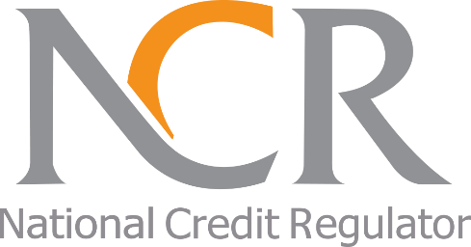
The National Credit Regulator
127-15th Road, Randjespark
Midrand
1685
Tel: (011)554-2600/2700
Website: www.ncr.org.za

MEDIA RELEASE
FOR IMMEDIATE RELEASE MARCH 2020

Avoid panic buying as it may lead to over-indebtedness

Many South Africans are overwhelmed, living in fear and anxiety because of the rapid escalation of the COVID-19 (Coronavirus) which presents an unprecedented threat to South Africa and the world at large. In recent times, we have seen many consumers resorting to panic buying of essential items as the fear of the Coronavirus spreads. The National Credit Regulator (NCR) is encouraging consumers to exercise caution and restraint when spending in this difficult period, says Nomsa Motshegare, Chief Executive Officer of the NCR.

Consumers are urged to make responsible financial decisions. Buying under panic and anxiety has the potential for consumers to buy things they do not need and cannot afford. For some consumers to acquire these items, they resort to using credit and this could be detrimental to their overall financial health. It is important for consumers to remember that credit comes at a cost and that the credit acquired has to be repaid, advises Motshegare.

Ms Motshegare further advises consumers who may be feeling financially distressed due to the impact of this pandemic to be proactive in addressing their finances and debt. Consumers are advised not to ignore their debts, but to contact their credit providers. Consumers can approach a debt counsellor for further assistance if over-indebted.

In light of the recent decrease of the interest rate, consumers should not increase their spending but rather use this opportunity to decrease their current debt and save for emergencies, concludes Motshegare.
ENDS

About The National Credit Regulator
The National Credit Regulator (NCR) was established as the regulator under the National Credit Act 34 of 2005 (NCA) and is responsible for the regulation of the South African credit industry. The NCR is mandated with the registration of Credit Providers, Credit Bureaus, Debt Counsellors, Payment Distribution Agents, and Alternative Dispute Resolution Agents; and monitoring their conduct in compliance with the National Credit Act as amended. The National Credit Regulator offers education and protection to consumers of credit in promotion of a South African credit market that is fair, transparent, accessible and dynamic.

For more information contact:
Media Office: media@ncr.org.za
Or
Ntombizodwa Mahlangu
(011) 554-2624 / 064 752 3926
E-mail: nmahlangu@ncr.org.za
Website: www.ncr.org.za

